Kevin Nunez Fall Linux Administration Lab1 09/09/2026
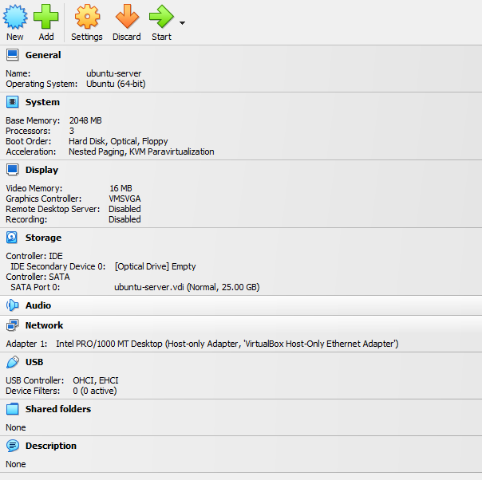
This is the Virtual Computer that I use for Ubuntu server, I use Oracle virtual machine for running this virtual server.
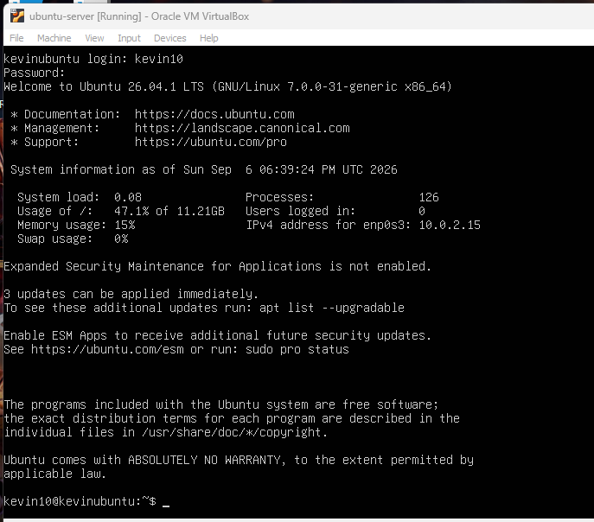
In this phrase I login to my ubuntu server and here I show how the server is set up and the server is working.
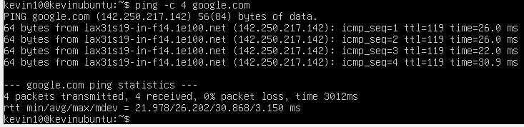
Now I ping the google page to check if the internet connection is working and this happened because I changed to bridge the network adapter, and now I can use internet in the ubuntu server.
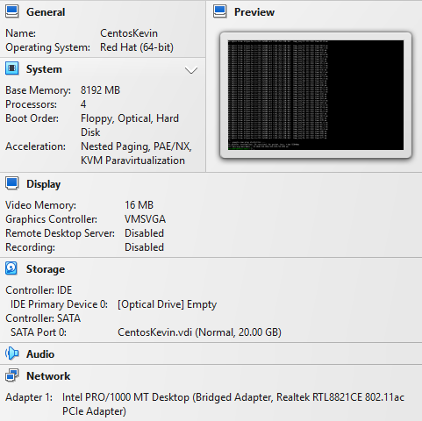
This is the configuration for the CentOS virtual machine; this machine I put more CPU because I want more fluency in this central machine.

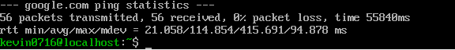
Here I ping the same google page but in CentOS for check is the internet is working on this one too.
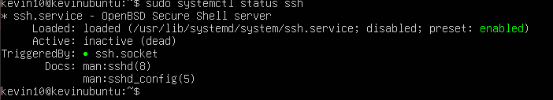
Here I activate the function for creating connections to other computers but more important with SmarTTY, and I did this on both virtual machines.
Now I create this file in the ubuntu server virtual machine, and I show the content of the file to see what is inside.
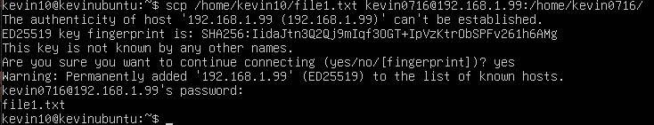
Now I am sending this file to the CentOs machine, and with this action I need to approve the credentials from the other server.
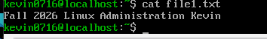
When I receive the file, I run the command to check what is inside and now I can see my file is there and I can read what is inside.
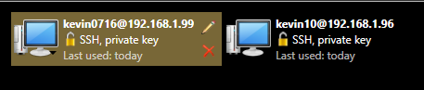
Here I show my two virtual machines on the SmarTTY platform where I create the connection.

